Following are the enhancements made
- Added converter script that changes the generated script in align with my page specification framework
- Added Settings page
- Generate script with plain text
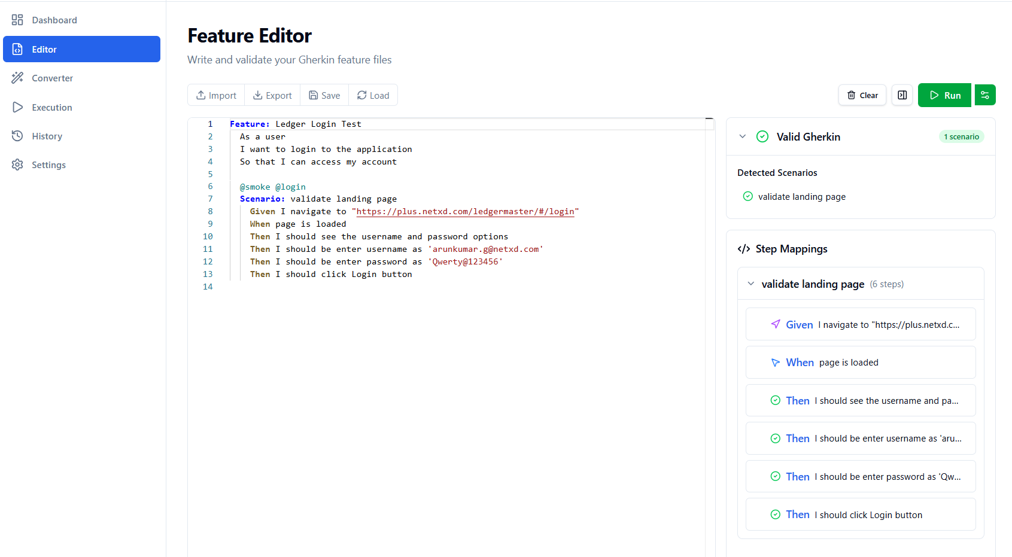
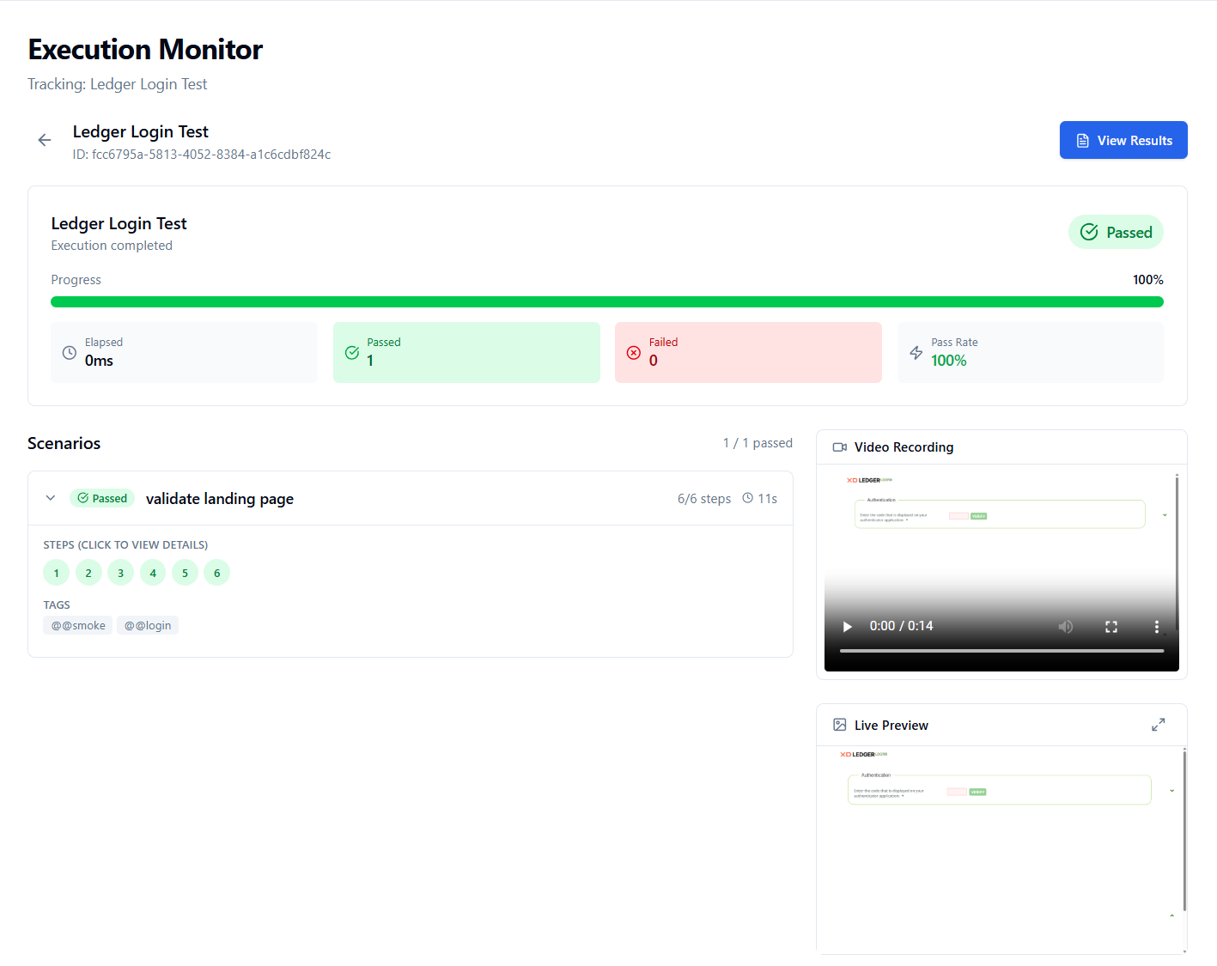
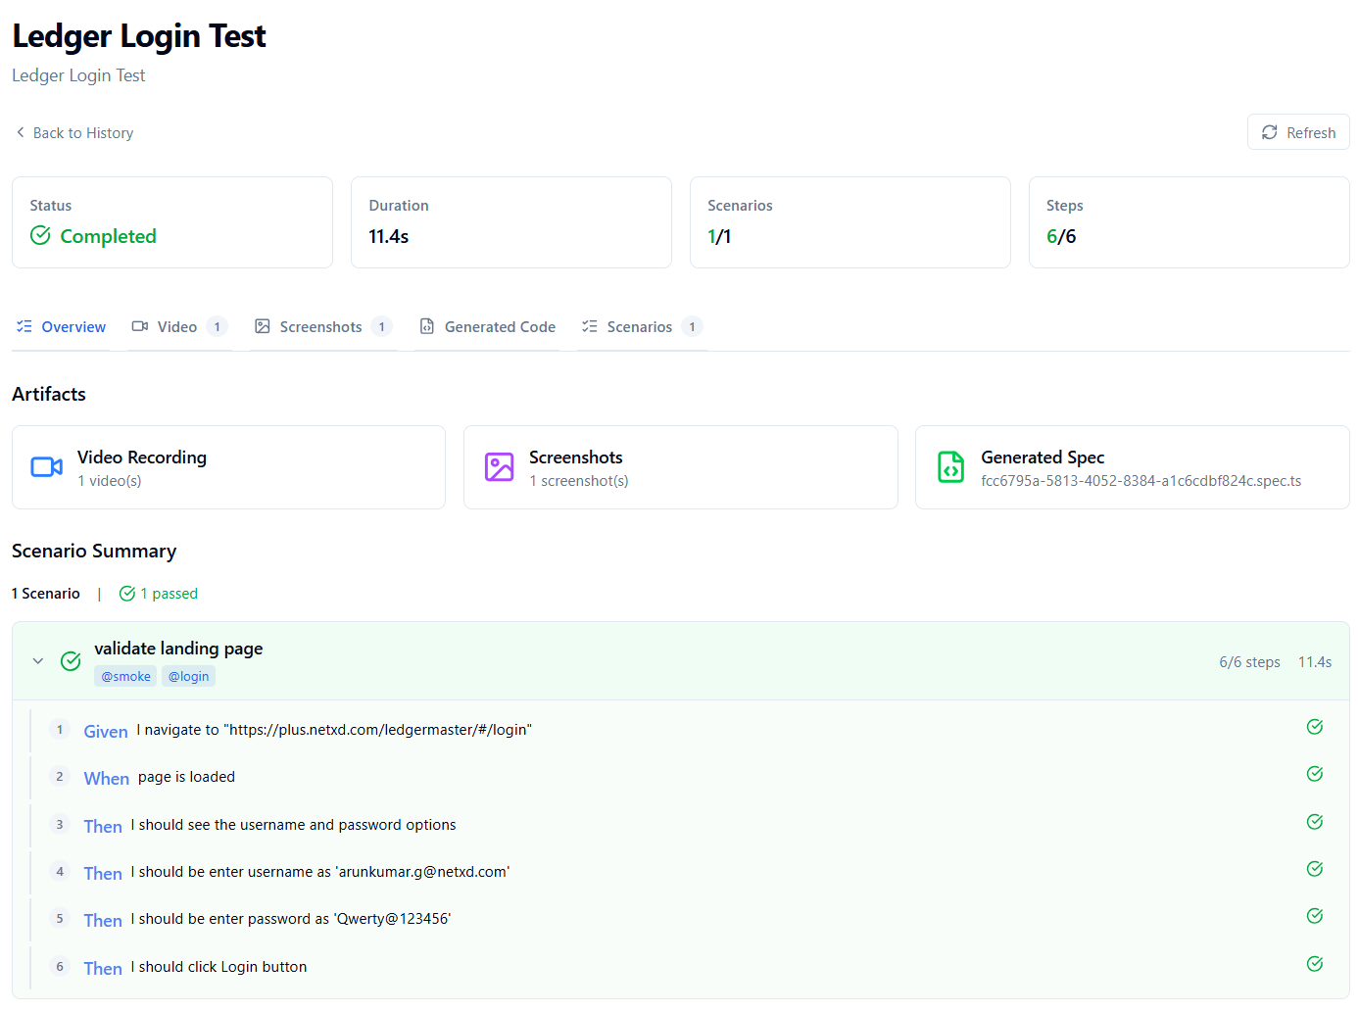
Added converter script that changes the generated script in align with my page specification
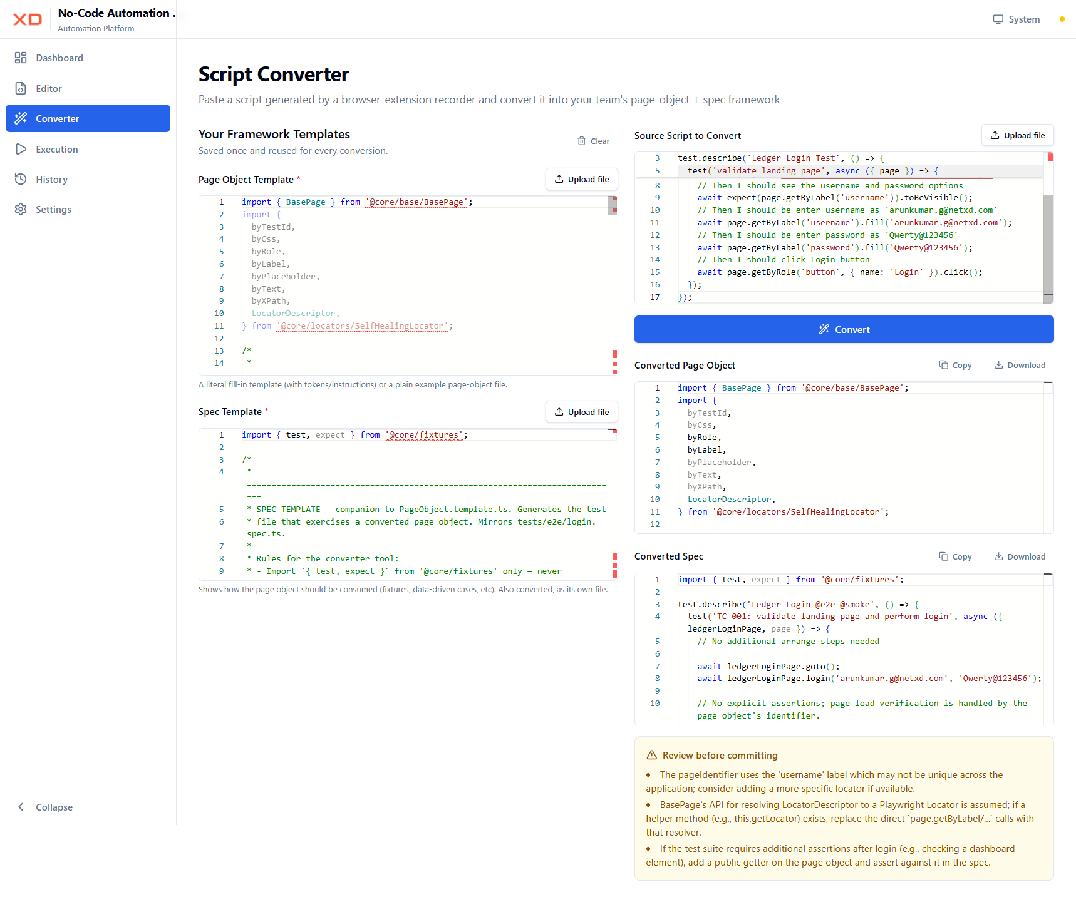

Converted Page Object
import { BasePage } from '@core/base/BasePage';
import {
byTestId,
byCss,
byRole,
byLabel,
byPlaceholder,
byText,
byXPath,
LocatorDescriptor,
} from '@core/locators/SelfHealingLocator';

export class LedgerLoginPage extends BasePage {
protected readonly pageUrl = '/ledgermaster/#/login';

protected readonly pageIdentifier: LocatorDescriptor = {
strategies: [byLabel('username')],
};

// ---------------------------------------------------------------------
// Locators
// ---------------------------------------------------------------------
private readonly usernameInput: LocatorDescriptor = {
strategies: [byLabel('username')],
};

private readonly passwordInput: LocatorDescriptor = {
strategies: [byLabel('password')],
};

private readonly loginButton: LocatorDescriptor = {
strategies: [byRole('button', { name: 'Login' })],
};

// ---------------------------------------------------------------------
// Business-facing actions
// ---------------------------------------------------------------------
private async fillUsernameInput(username: string) {
// Using the raw Playwright locator for simplicity; adjust if BasePage provides a resolver.
await this.page.getByLabel('username').fill(username);
}

private async fillPasswordInput(password: string) {
await this.page.getByLabel('password').fill(password);
}

private async clickLoginButton() {
await this.page.getByRole('button', { name: 'Login' }).click();
}

public async login(username: string, password: string) {
await this.fillUsernameInput(username);
await this.fillPasswordInput(password);
await this.clickLoginButton();
}
}

Converted Spec
import { test, expect } from '@core/fixtures';

test.describe('Ledger Login @e2e @smoke', () => {
test('TC-001: validate landing page and perform login', async ({ ledgerLoginPage, page }) => {
// No additional arrange steps needed

await ledgerLoginPage.goto();
await ledgerLoginPage.login('arunkumar.g@netxd.com', 'Qwerty@123456');

// No explicit assertions; page load verification is handled by the page object's identifier.
});
});

Implemented Settings Page
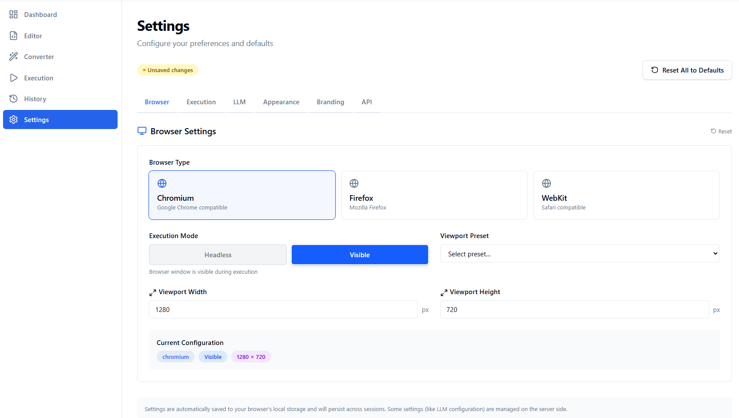

Executed in different devices
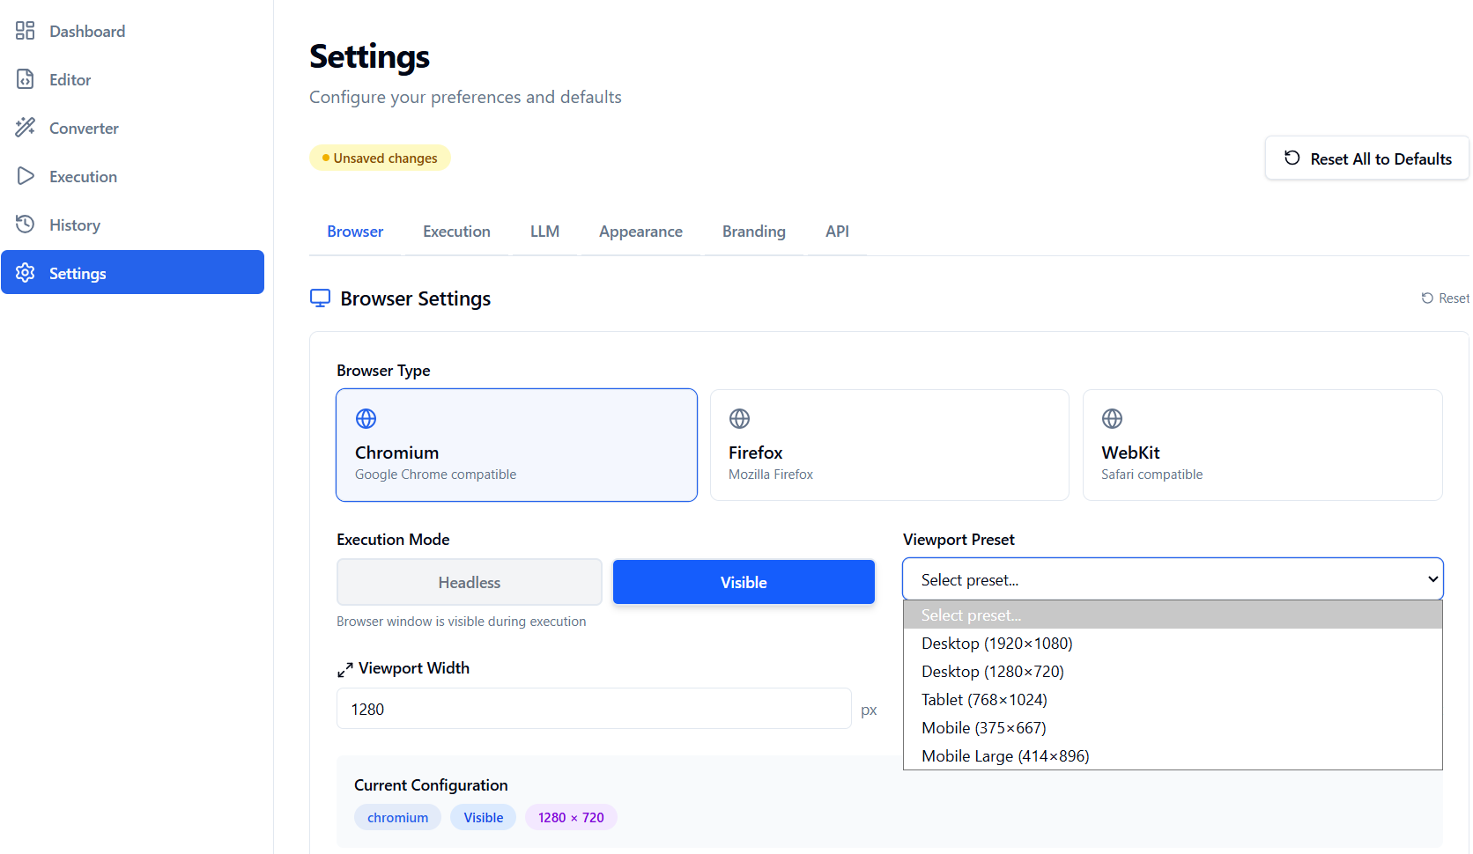

LLM models are configurable
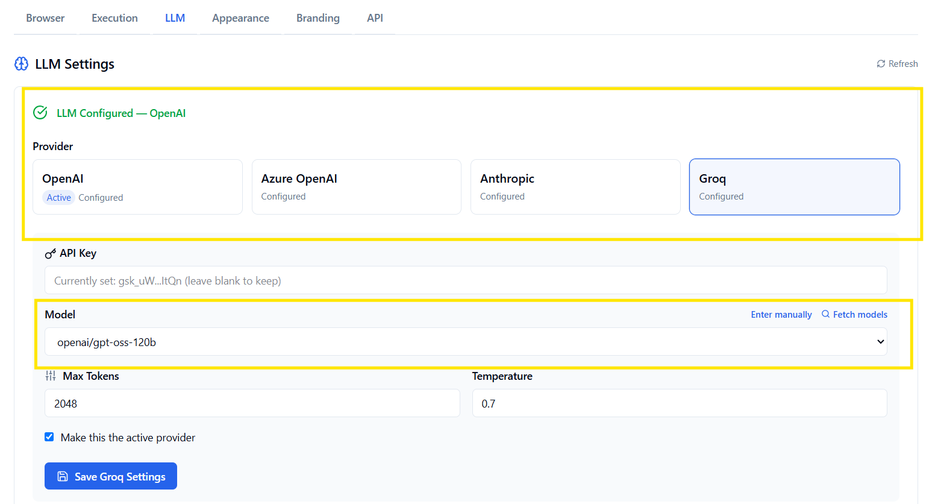
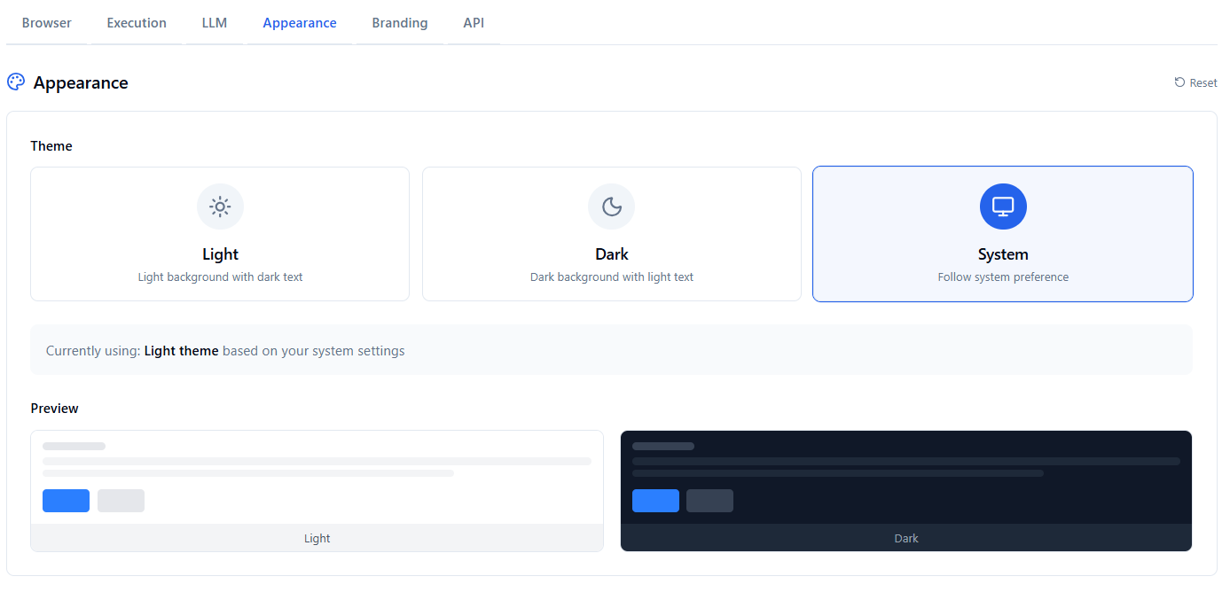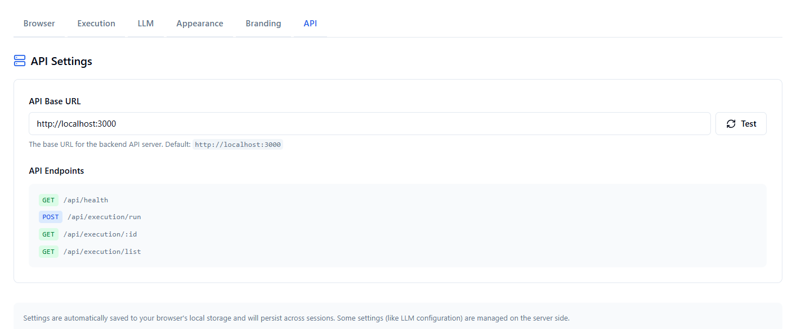

Script generated with plain text
